Continuous Integration and Continuous Deployment Lab

Experiment – 8

**Name : Harivansh Mathur**

**Roll No : R171218043**

**Implementing Master/Slave Architecture in Jenkins**

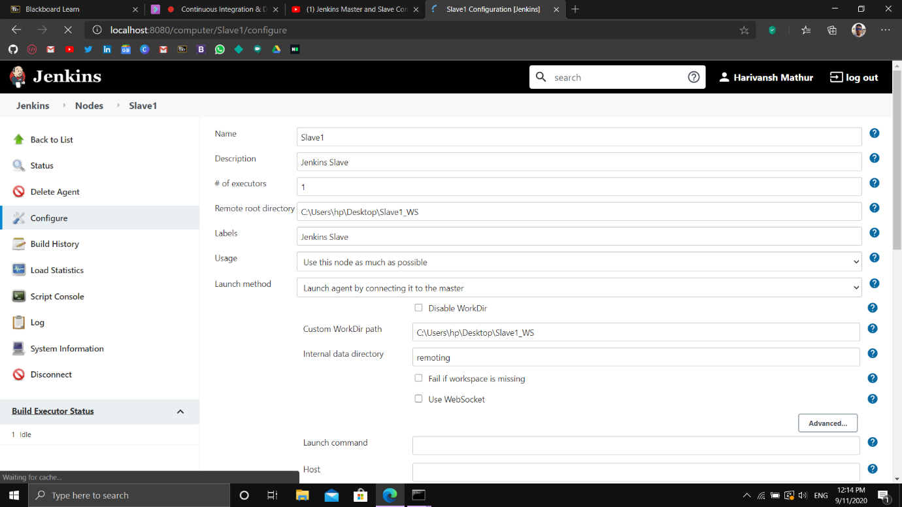

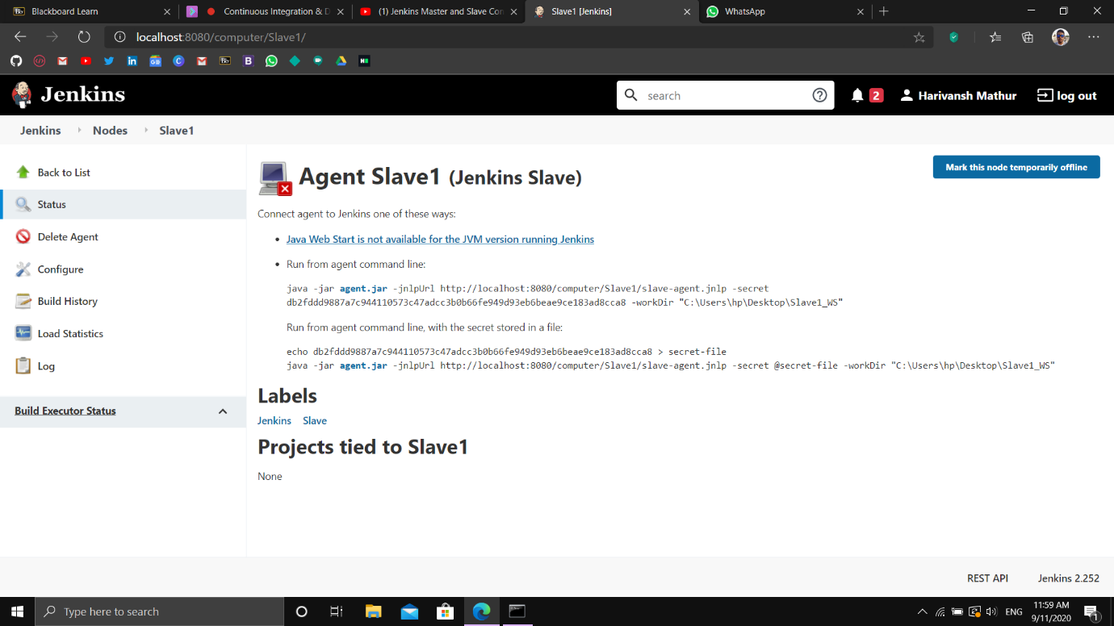

Creating a slave node in Jenkins

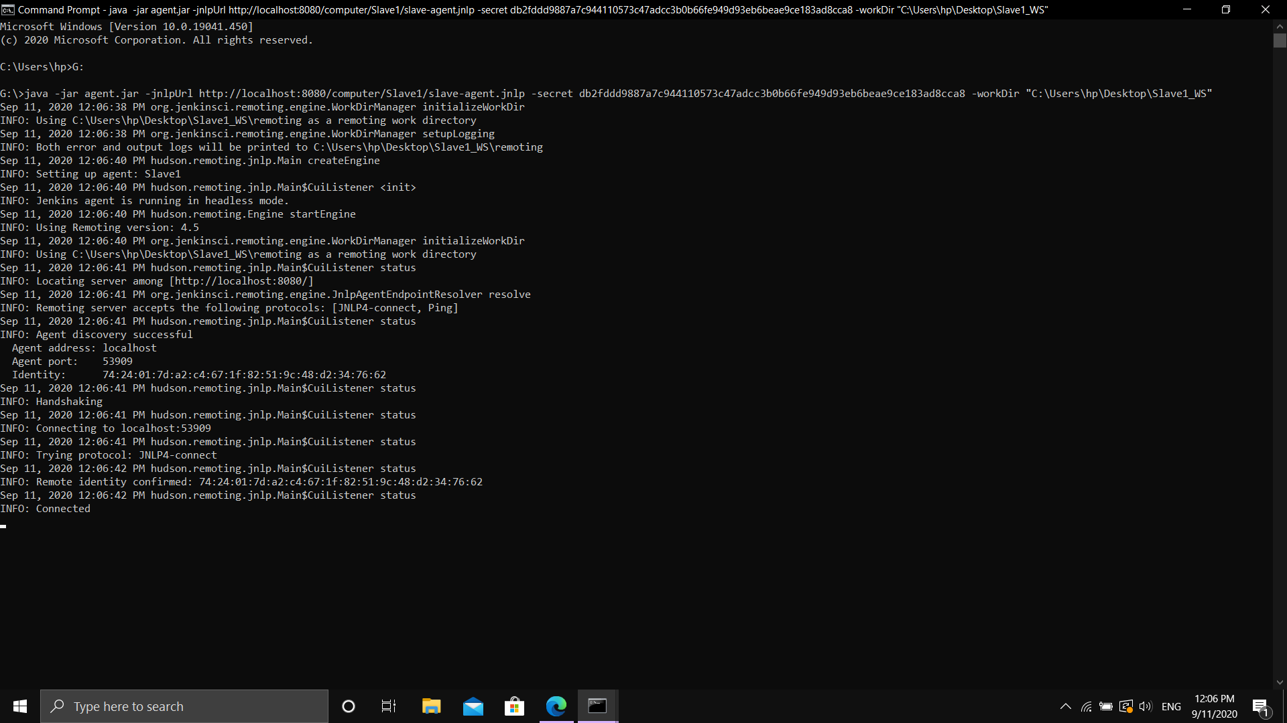

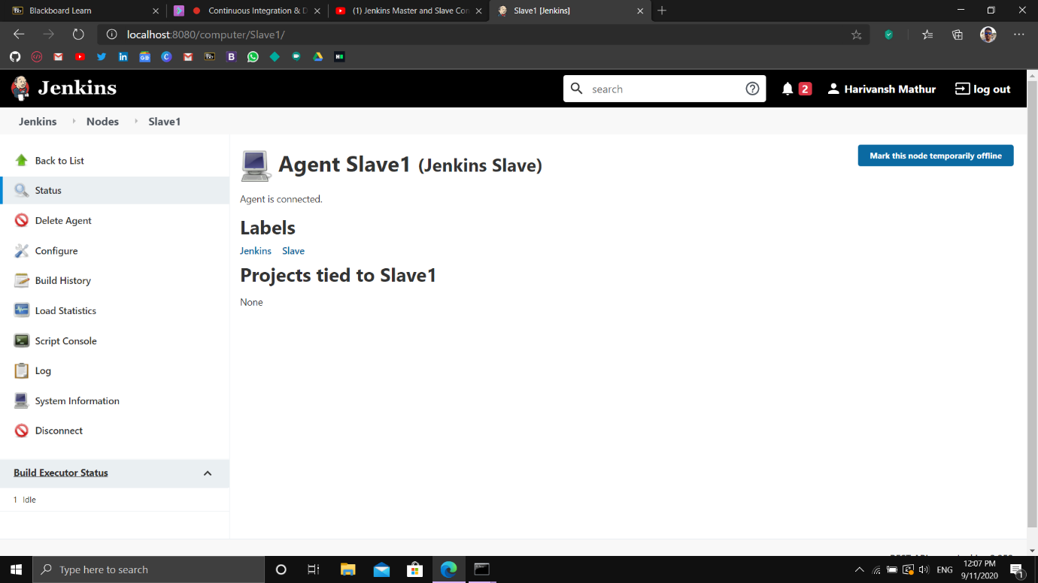

Making a Maven Project and connecting it with the slave node

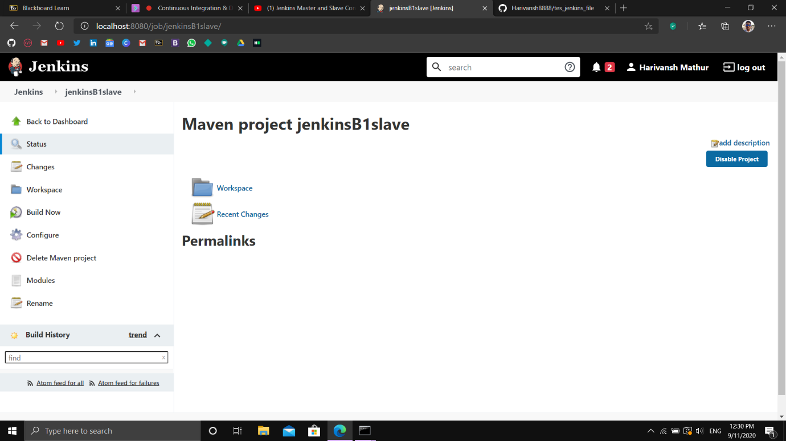

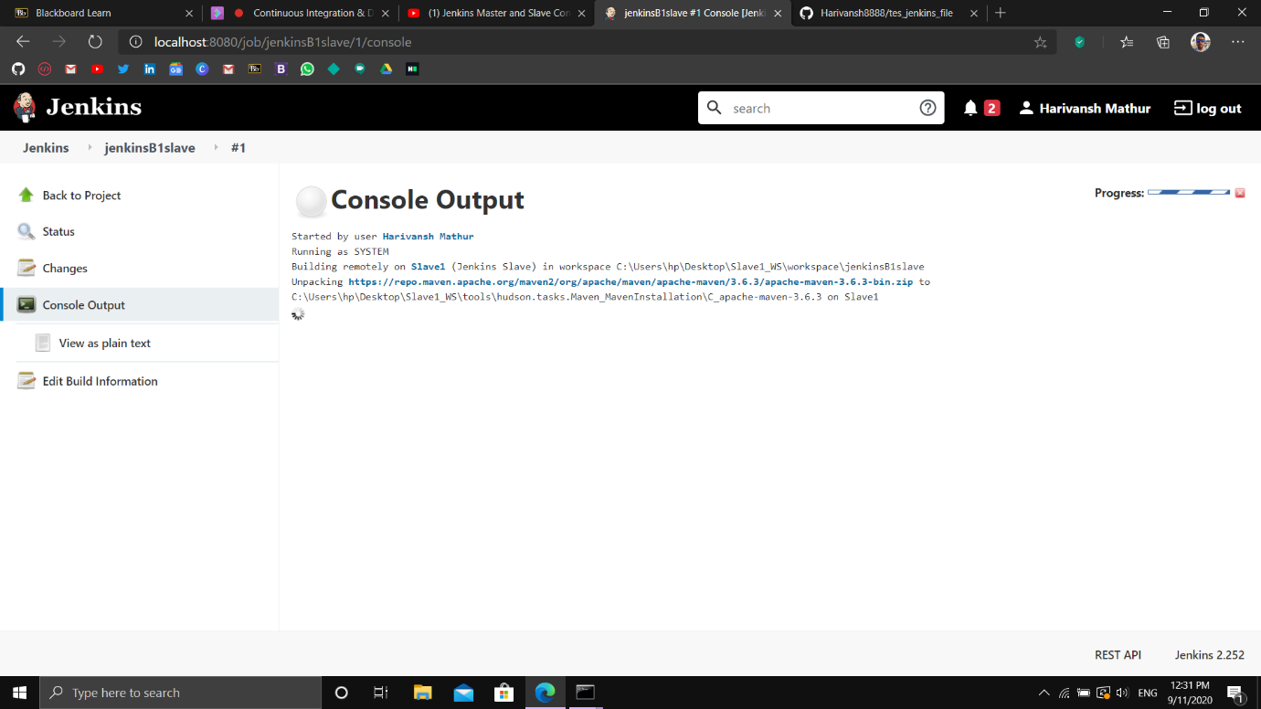

Building the maven project on Slave Node

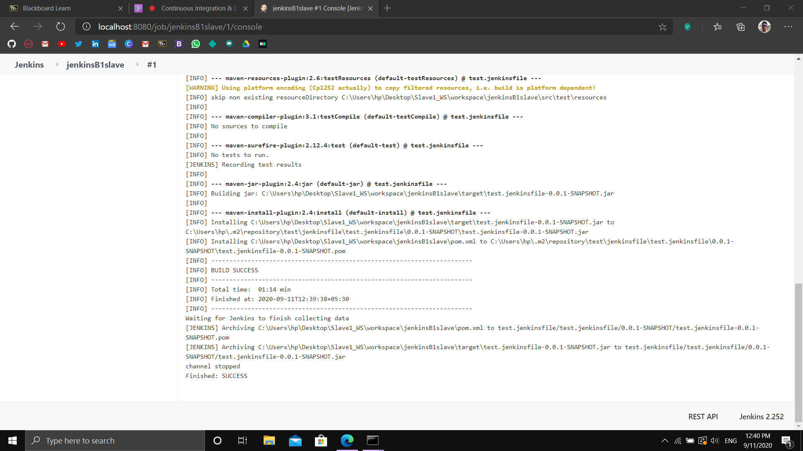

Build Success